Leinster Property Snags
Richard Holohan 089 6123598



Address_______________

Inspection of the property
Thursday 26th January 2023
Prepared for Name

Summary
An inspection of the above mentioned property has been carried out on behalf of the purchaser. Property was in a very clean condition and ready for snagging.The weather was dry and sunny on the day of Inspection. The water and electricity were both connected.The following list of works needs to be completed to the satisfaction of the purchaser prior to the closing of the sale. Sewer and storm lines need to be flushed out to make sure that there is no debris left in the lines.

Front Elevation
- Repair chip to the bottom face of the office window sill. Photo 1
- Repair crack in the plaster over the stop bead over the LHS of the canopy roof. Photo 2
- Clean scuff marks on the plaster to the RHS of the entrance door. Photo 3
- Clean plaster splashes on the sitting room window sill. Photo 4
- Fix loose vent cover in the plinth. Photo 5
- Remove plastic in the gutter over the bedroom window.
- Remove off cut of roof tile in the LHS valley.
- Complete landscaping around the fence post on the boundary. Photo 6

Side Gable Elevation
- Seal hole around the overflow pipe from the water tank in the attic. Photo 7
- Touch up the vertical mortar joint between the stonework and the plaster stop bead.
Photo 8
- Clean marks on the plaster.
- Clean soil pipes.
- Fit cover grating on the gulley. Photo 9
- Clean plaster on the window sill beside the utility entrance door. Photo 10
- Clean marks on the outside of the utility entrance door.

Rear Elevation
- Replace broken glass panel in the side panel of the French doors.
- Paving slabs on the top of the step at the French doors are loose.
- Fit cover to the vent pipe in the plinth to the LHS of the French doors. Photo 11
- Touch up uneven plaster on the plinth behind the outdoor unit. Photo 12
- Clean staining to the bottom of the wall at the rainwater down pipe. Photo 13 • Fill hole in the plaster reveal to the bottom LHS of the French doors. Photo 14
- Seal the joint between the plaster reveal and the French door frame.
- Remove protection film and clean marks on the threshold to the French doors.

Entrance Hall

- Remove paint marks on the entrance door and frame.

Store Under the Stairs
- Water leak showing at the indoor unit. Photo 15
- Fill the hole in the floor around the heating pipes. Photo 16 • Adjust the receivers in the two doors to stop the doors rattling.

Sitting Room
- Adjust the receiver in the the door to stop the door rattling.
- There are scratch marks on the top and bottom left hand panes of glass.
- Fix receiver plate in the frame for the flush bolt in the double doors.

Kitchen/ Dining Room
- Scratch mark on the glass of the right hand French door.
- Adjust the receiver on the hall door to stop the door rattling.
- Clean paint marks on the plinth of the kitchen units to the LHS of the window.
- Seal the end of the work top and the splashback to the wall.
- Window sash a little stiff when opening.

Utility
- Adjust the receiver to stop the door rattling.
- Finish coat of paint required on the skirting under the work top.
- Seal the joint between the external door frame and the reveal.

Office
- The door catching in the frame but will probably be ok when the heating is turned on.
- Adjust the receiver to stop the door rattling.
- Scratch marks on most panes of glass.

W/C
- Adjust the receiver to stop the door rattling.
- Toilet bowl is slightly at an angle.
- Window sash very stiff when opening.
- Fill the top of the skirting at the architrave

Stairs/Landing
- Touch up scuff marks on the walls.
- Fill the top end of the skirting to the RHS of the store room door.
- Touch up marks on the ceiling over the stairs

Main Bedroom
- Repair chip marks on the top of the door on the outside and on the locking stile.
- Adjust the receiver to stop the door rattling.
- Touch up marks on the ceiling inside the door.
- Seal the joint between the gable end of the wardrobe and the wall.

Ensuite
- Adjust the receiver to stop the door rattling.
- Fill the end of the skirting to the LHS of the shower door.

Front Bedroom LHS
- Adjust the receiver to stop the door rattling.
- Repair chip mark on the architrave beside the receiver.
- Fill the top of the skirting behind the radiator where visible.
- Touch up mark on the wall under the window.
- Right hand window sash needs adjustment.
- Fit cap in the screw head in the wardrobe on the RHS.

Back Bedroom LHS
- Adjust the receiver to stop the door rattling.
- Trim excess spray foam around the radiator pipes. • Seal the joint between the wardrobe and the wall.

Bathroom
- Adjust the receiver to stop the door rattling.
- Seal the joint between the tile trim around the splashback and the wall.
- Fix screw caps on the screw heads around the bottom of the bath panel.
- Seal the joint between the wash basin and the wall.
- Fill around the radiator pipe to the RHS of the towel rail. Photo 17

Storeroom
- Adjust the receiver to stop the door rattling.

Attic
- Remove excess mortar. Photo 18
- Refit any attic insulation that has been displaced.

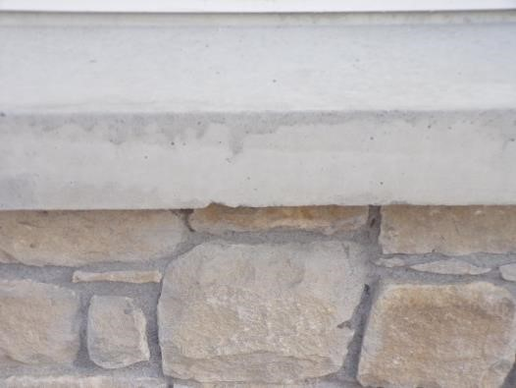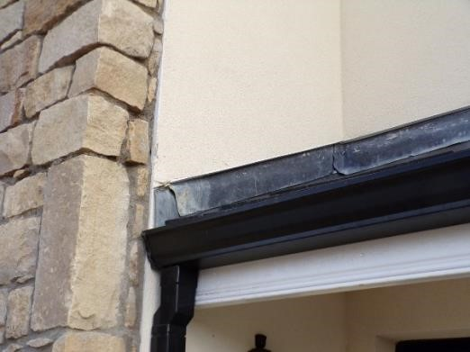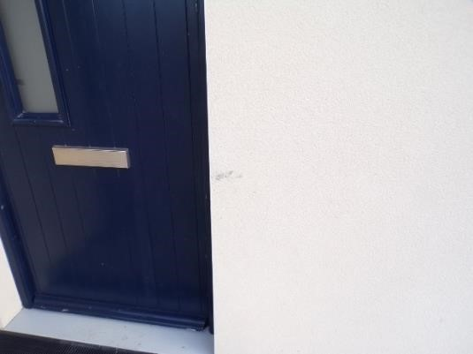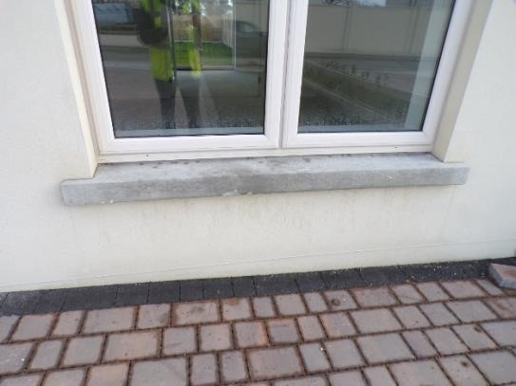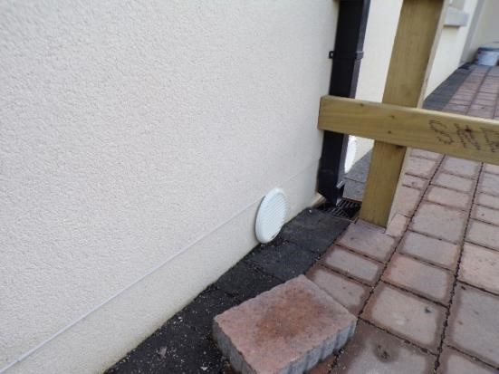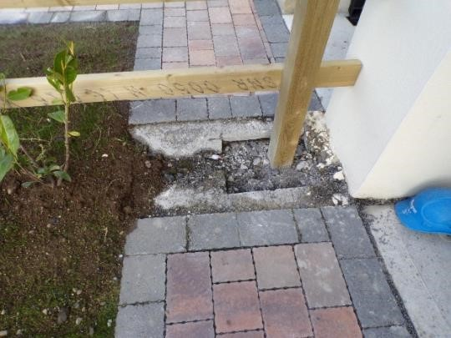
1

2

3

4

5

6

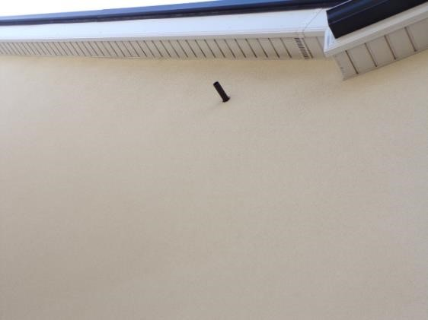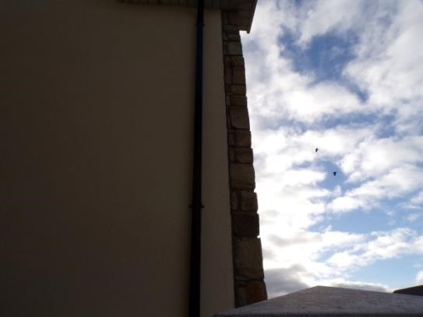
7

8

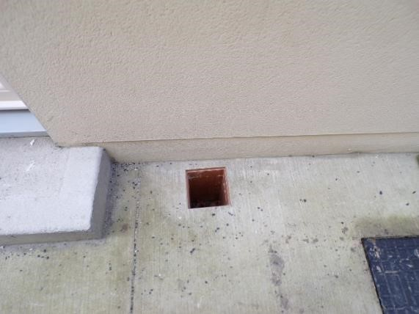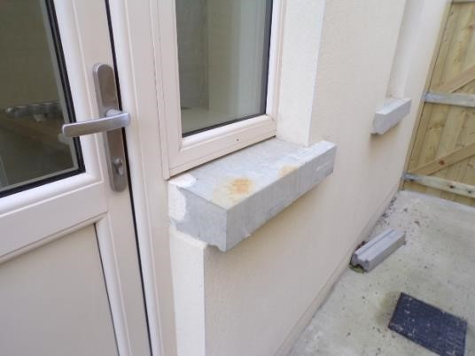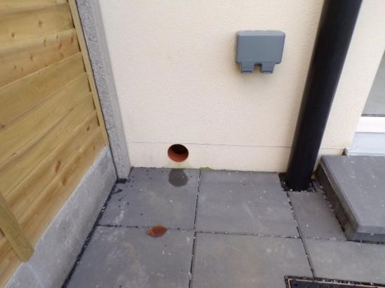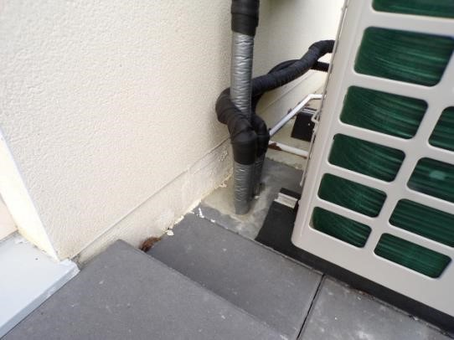
9

10

11
12

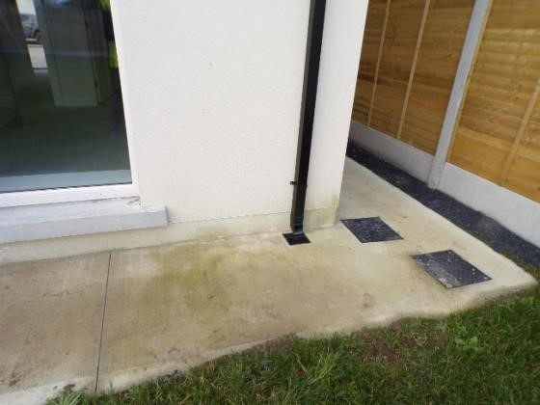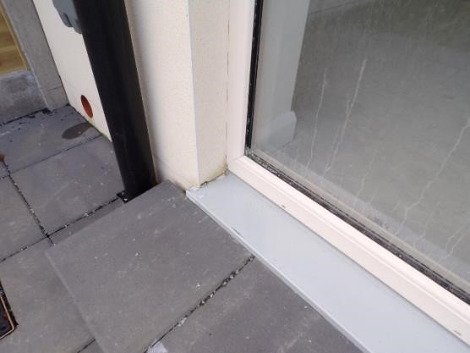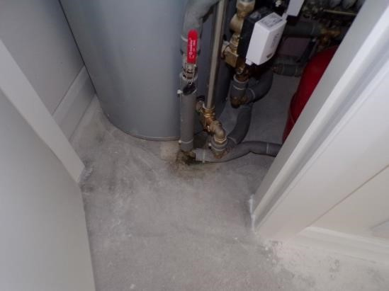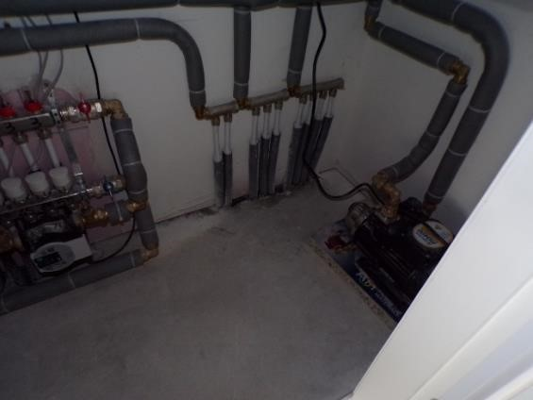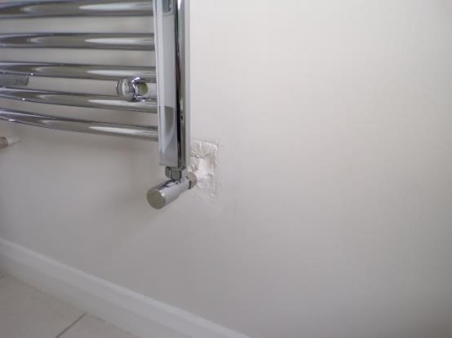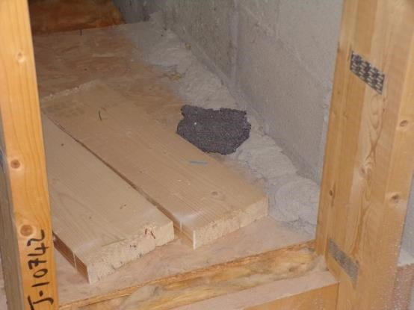
13

14

15

16

17

18

